Module 2

ASSIGNMENT NAME: configure a development environment

SITE DESCRIPTION

My site will be of a college website where announcement will be made, upcoming events and also the school photo gallery. The visitors will be able to get information from the website.

VIRTUAL MACHINE

<http://patel3.centralus.cloudapp.azure.com/wildfire/module2/index.html>

GIT HUB REPOSITORY

<https://github.com/shyam13/myProject>

Screen shots( desktop)

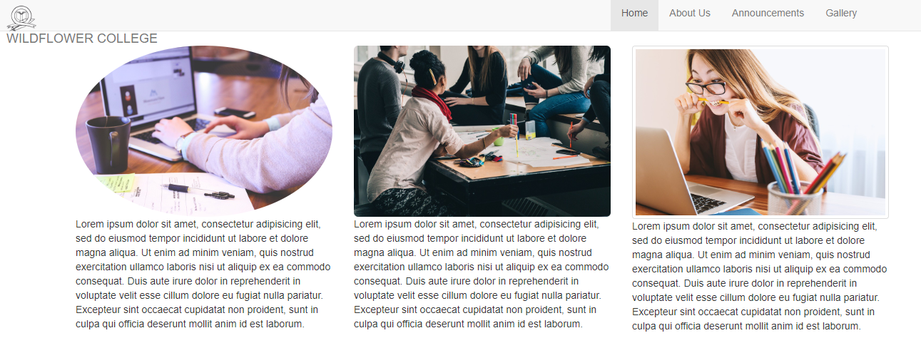

**Screenshot (mobile)**